**WEB TECHNOLOGY LAB**

**EXPERIMENT NO. 7: MAZE GAME**

**AIM :** To create a QUIZ APPLICATION using HTML, CSS, JavaScript.

**DESCRIPTION** **:**

This project uses HTML 5, CSS 3, JavaScript. It is an WEB APPLICATION.

This project uses HTML 5, CSS 3, JavaScript. It is an WEB APPLICATION.

HTML(Hyper Text Markup Language) is the standard markup language for Web pages. With HTML you can create your own Website.

CSS(Cascading Style Sheet) is a language that describes the style of an HTML document. CSS describes how HTML elements should be displayed.

JavaScript is the programming language of HTML and the Web. JavaScript is used to program the behaviour of web pages.

In this game user is initially is present at any random position on the maze and he have to reach the last

Position of the maze.

**Flow of the project:**

1. Initially The start page is displayed. On this page first the maze is loaded.
2. After loading the maze, the user has to start the game by pressing any key.
3. After pressing any key, the user has to move in the direction through which

the path is possible by pressing the arrow keys for respective directions.

1. A timer is started when the user presses any key for the first time.
2. This timer will count 30 seconds and the user has to finish the game within 30 seconds if he fails to do so, he will lose the game.
3. After 30 seconds the game is over and the respective message for win or lose is displayed.

**OUTPUT :**

**1. Start Page: Loading window**

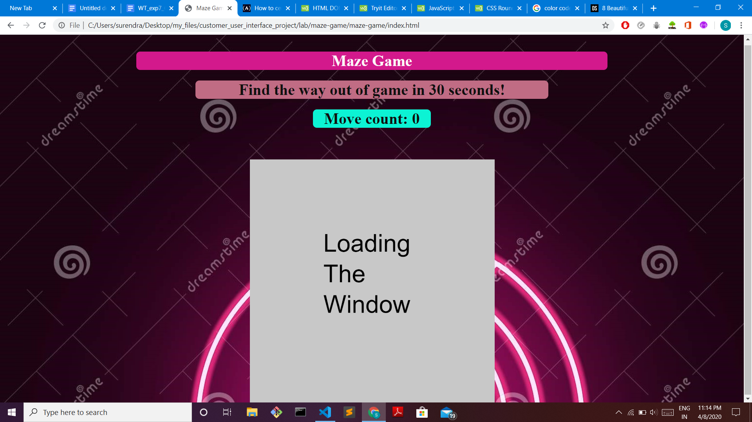

**2. Starting the game**

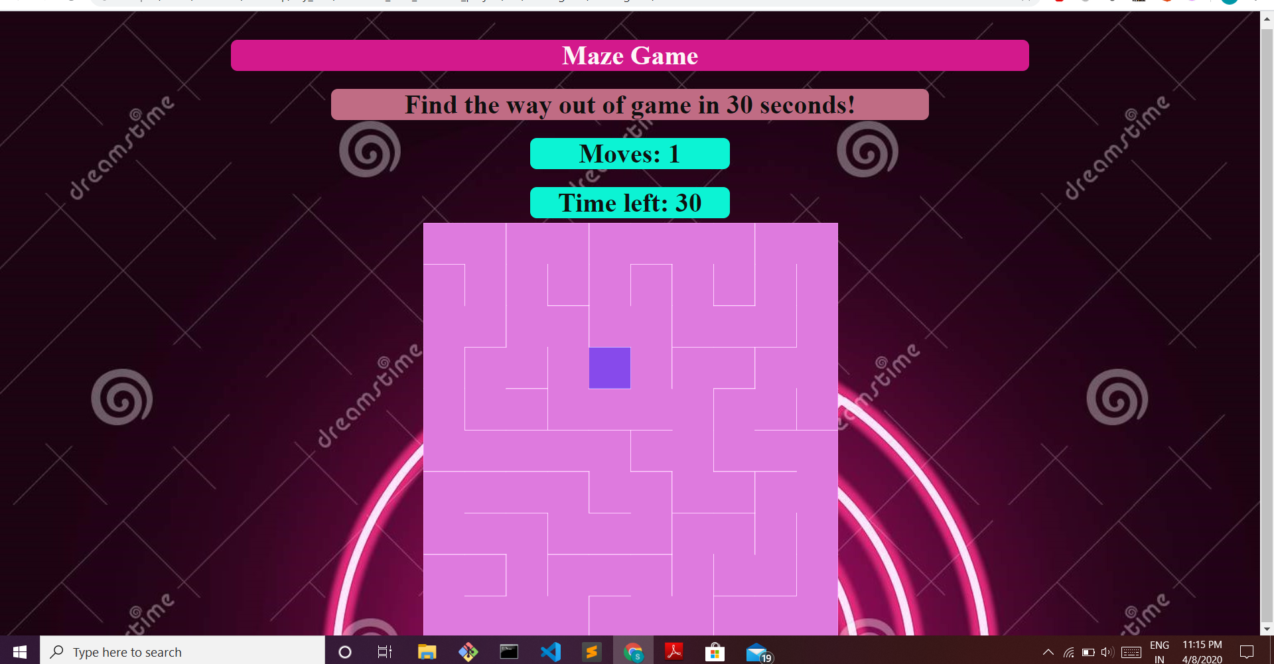

**3.Winnig The Game**

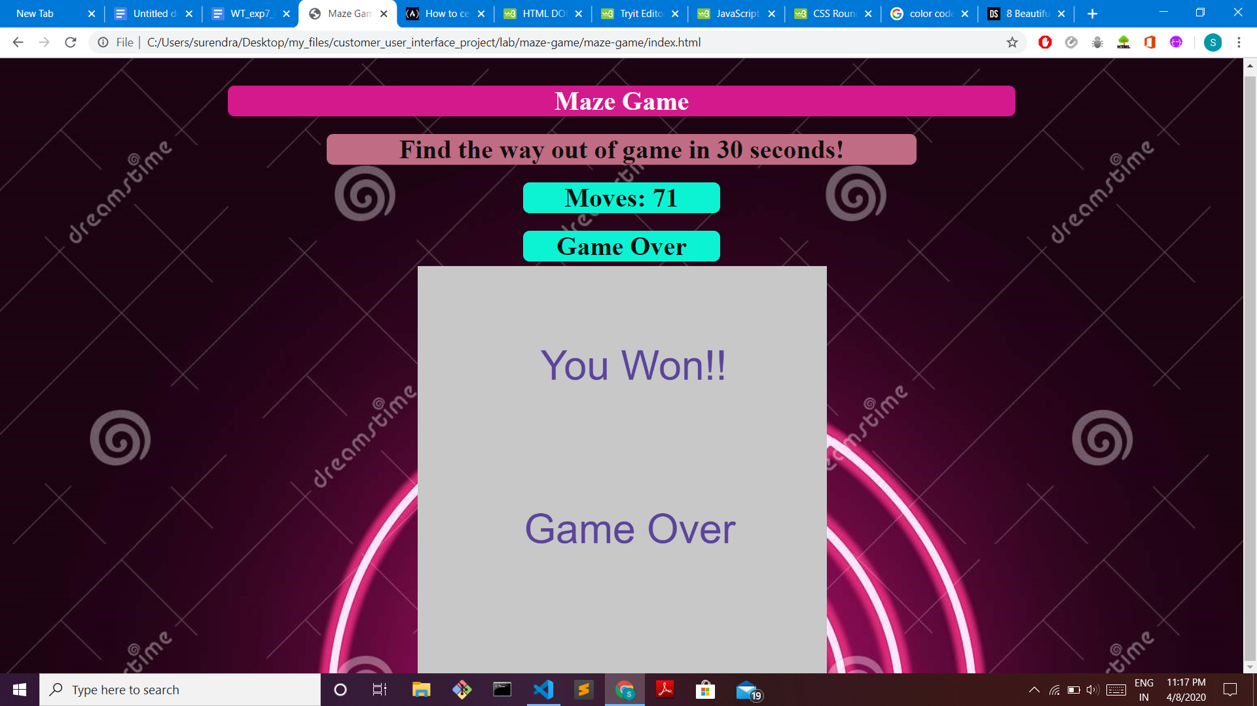

**4. Losing The Game**

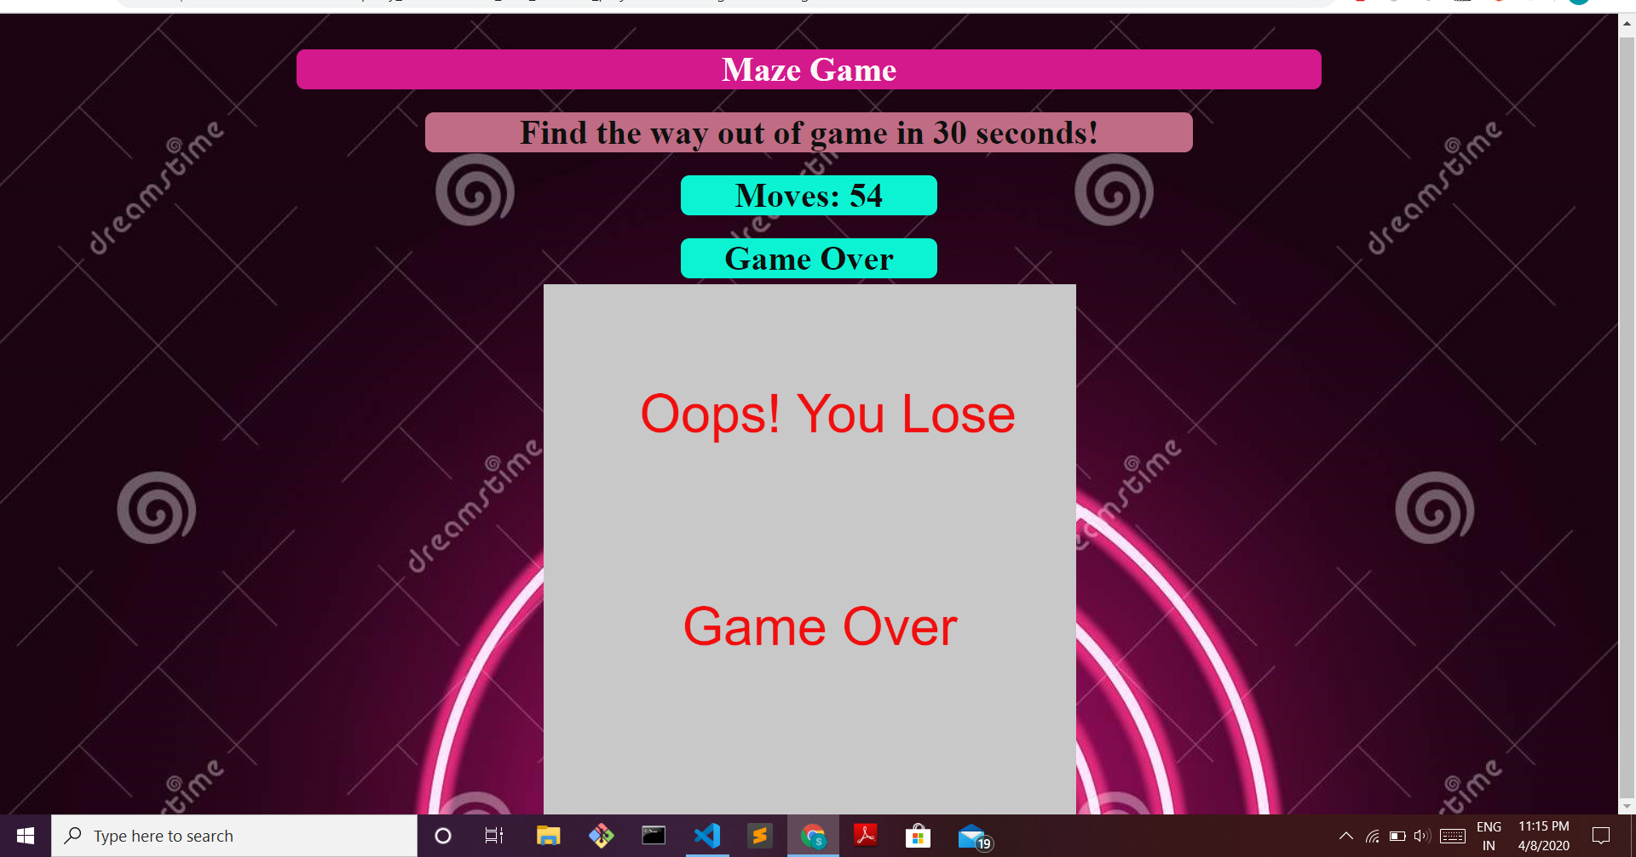

**Conclusion :**

Hence the maze game has been Made by using HTML, CSS, And JavaScript.